Review and redesign of Lancashire's short break offer – parent and carer consultation

Consultation report – 2021

Mike Walker, Hanif Patel and Melissa Sherliker

January 2021

For further information on the work of Business Intelligence please contact us at
Business Intelligence
Lancashire County Council
County Hall
Preston
PR1 8XJ
Tel: 0808 1443536
www.lancashire.gov.uk/lancashire-insight

Contents

1. Executive summary 3

1.1 Key findings 3

2. Introduction 5

3. Methodology 9

3.1 Limitations 10

4. Main findings 11

4.1 The children respondents care for 11

4.2 Use of short break services 12

4.3 Respondents' views on the proposals 13

Appendix 1 – respondent demographics 41

Executive summary

This report summarises the response to Lancashire County Council's consultation on the proposal to review and redesign Lancashire's Short Break offer.

The consultation ran for six weeks between 1 September and 14 October 2020, using a self-completion questionnaire to gather feedback on the proposal. Both a paper and online option of the questionnaire were circulated and made available for completion. An electronic version of the consultation questionnaire was also available online at www.lancashire.gov.uk.

A total of 205 responses were received.

Previous feedback received from parents, carers, short break providers and children and young people as part of the review and redesign of Lancashire's Short Break Offer has informed the design of the new proposed Short Break Offer.

1.1 Key findings
1.1.1 The children respondents care for
- Almost half (48%) of respondent households said that they had a child aged 11-16 with special educational need and/or disability and just over two-in-five (43%) respondent households has a child age 6-10 with special educational need and/or disability.
1.1.2 Use of short break services
- A third (33%) of respondents currently use a short break service, and just over a quarter (28%) have previously used a service but are not currently using.
- Respondents who currently use or have previously used Lancashire's Short Break service were then asked what type of short break service they had used. Of these respondents, almost three-fifths (59%) used the Lancashire Break Time activities service and one-in-nine respondents (11%) used the day time short breaks service.
1.1.3 Respondents' views on the proposals
It is proposed that the age range for access to Break Time activities is 5 to 18 years old. A child would be able to attend from the start of the academic year (September) in which they turn age 5 to the end of the academic year in which they turn 18 (July).
- Just over a third (36%) of respondents strongly agreed with the proposal and a third (33%) of respondents tend to agree with the proposal.
It is proposed that a child can attend a minimum of 10 hours and a maximum of 50 hours of activities or groups per year as part of the Break Time offer.
- Almost three-in-ten (28%) respondents strongly disagreed with the proposal. Four-in-ten (40%) of current users and the same proportion of previous users strongly disagreed with the proposal.
- Respondents who disagreed with the proposed minimum and maximum hours, were asked what they thought the maximum number of hours per year should be. Almost three-in-five (59%) of respondents through the maximum should be more than a 100 hours per year.
It is proposed that the minimum parent/carer contribution towards Break Time activities and groups is increased from £1 per hour to £2 per hour.
- Almost one-in-three (28%) respondents strongly agreed with the proposal and almost a third (32%) tend to agree with the proposal.
It is proposed that the costs of specific Break Time activities, entrance fees and transport should be paid by parents/carers and not through Break Time funding.
- About one-in-three (31%) respondents strongly or tend to agree with the proposal and almost two-in-five (37%) respondents disagreed with the proposal. Current users were more likely to agree with the proposal (39%) and less likely to disagree (29%).
It is proposed that children with a plan of care and support following a social care assessment will be able to access Break Time activities and groups through Break Time Plus. These children would not be funded by Break Time funding.
- Almost one-in-three (29%) respondents either strongly or tend to agree with the proposal and almost a quarter (24%) strongly or tend to disagree with the proposal. Current users were more likely to agree with the proposal (35%) and were also more likely to disagree with the proposal (29%).
It is proposed that that the allocation of a Break Time offer is prioritised for children with an education, health and care plan by date order of application.
- Two-in-five (40%) respondents either strongly or tend to agree with the proposal and just over a third (36%) strongly or tend to disagree with the proposal. Previous users were more likely to disagree with the proposal (51%).

Introduction
The consultation was for all parents and carers of children and young people with special educational needs and disabilities (SEND) who are currently using Lancashire's Short Break Service, have used it in the past or who haven't used it before.

Throughout the consultation the words child or children are used to mean children and young people up to the age of 18.

Our current Short Break Offer for children with SEND
The Short Break Offer in Lancashire consists of activities and services that can be accessed by children with SEND and their families if children meet certain eligibility criteria. These activities and services can be accessed without a social care assessment of need. These include inclusive activities, groups and events specifically for children and young people with SEND which form part of the Early Help Offer; and Lancashire Break Time.

The Short Break Offer also includes support and services which can only be accessed through social care assessment of need.

Lancashire Break Time provides group activities which are aimed at providing a short break for parents and carers.

Day Time short breaks can be provided in the family home, in the community or in other places. Day Time short breaks may be funded through a personal budget (Direct Payments) or commissioned by Lancashire County Council from a short break provider.

Night Time short breaks can be provided in the family home, a specialist short break children's home, by foster carers or in the home of short break carers. Night Time short breaks may be funded through a personal budget (Direct Payments) or commissioned from a short break provider or carers.

Proposed new Short Break Offer
It is proposed that our new Short Break Offer will provide Break Time, Day Time and Night Time short breaks alongside the Early Help Offer for children with SEND and other activities provided by various charities and organisations across Lancashire.

It is proposed that there will be no changes to how children and families access Day Time and Night Time short breaks.

Contracts for Break Time activities will be recommissioned and a different approach taken to improve how we meet needs, provide quality support, choice, value for money and a more consistent offer across the county.

The proposed changes to the Short Break Offer that form part of this consultation relate to the Short Break Offer that can be accessed without a social care assessment of need. This is currently called Lancashire Break Time. In the new offer it will be called Break Time.

Proposed Break Time Offer
It is proposed that the criteria and process for accessing Break Time activities is changed to make sure access to Break Time is fair, clear and transparent. The Short Break Review identified significant differences in the amount of hours some children were accessing across Lancashire. It also identified that some children who didn’t fit the criteria were attending Lancashire Break Time.

Current offer – Lancashire Break Time | Proposed new offer - Break Time
Lancashire Break Time provides group activities which provide a short break for parents and carers. | Break Time activities provide an opportunity for a short break for parents, carers, families and children and young people through children and young people being part of a group activity.
Eligibility criteria for Lancashire Break Time  A child or young person must:  - be living with an unpaid carer;  - be aged between 4 to 18 years;  - living in Lancashire, excluding Blackburn with Darwen and Blackpool;  - find it difficult to access universal services due to sensory issues, learning difficulties and/or physical mobility problems;  - not be in receipt of an assessed social care outreach package. | - Children will be able to access Break Time from the start of the academic year (September) in which they turn age 5 to the end of the academic year in which they turn 18 (July)  - Children will have special educational needs and/or disabilities and be unable to access universal services and activities.  - Children will live in Lancashire (excluding Blackburn with Darwen and Blackpool council areas)  - A child is eligible to attend Break Time if:  - Parents or carers are in receipt of child benefit for a child  - Parents or carers receive a carers allowance for a child  - Children are not eligible to attend Break Time if:  - They are looked after children and live with their parents, in a foster family or in a children's home  - They have had a social care assessment and receive Day Time or Night Time short breaks following this, through a Child's Plan (social care plan of support).  - They attend a residential school or receive short breaks as part of school support to families
Children are able to access as many Lancashire Break Time activities and groups as they wish (subject to availability) | Children will be able to access a Break Time activities and groups of between 10 and 50 hours a year.  The Short Break review identified that more than 60% of children attended fewer than 50 hours of Lancashire Break Time activities. 1% of children attended more than 400 hours of activities. A maximum of 50 hours Break Time Offer should meet the majority of children and families' needs within the budget provided for Break Time activities.  Families will be able to purchase additional hours of Break Time activities if they want to access more than the maximum offer of 50 hours and this will form part of the new commissioning arrangements.  If families do not feel the Break Time offer meets their needs then they can request a social care assessment of need.
There is a minimum parental contribution of £1 per hour towards Lancashire Break Time activities (paid directly to the activity provider) in addition to the cost of specific trips/activities. | It is proposed that the minimum parent carer contribution to Break Time activities is increased from £1 to £2 per hour, paid directly to the provider.  The minimum parent carer contribution would be in addition to any specific costs of activities, entrance fees or transport to or as part of Break Time activities. These costs would not be funded through Break Time funding.
Activities are arranged directly by parents and carers with individual providers who have a contract with Lancashire County Council to provide Lancashire Break Time activities. | Families will apply to Lancashire County Council for Break Time hours once a year by a set date.  Families can choose which provider/providers they wish their child to attend activities and groups with, though how many providers can be chosen may need to be limited to enable providers to effectively deliver these.  Break Time funding will be given directly to the provider/providers in advance, giving an increased level of financial security for providers which will support them to plan ahead and invest in arrangements, staffing and training. This will also help families to plan ahead.
No clear, transparent, consistent system of allocating places on Lancashire Break Time activities and groups. Providers have their own processes for allocating places. | It is proposed that applications and the allocation of a Break Time offer will be prioritised for children with an education, health and care plan by date order of application. This will enable children with the greatest levels of need and who are least likely to be able to access universal services and activities to be supported through Break Time.

Other information about the proposed new Short Break Offer
It is proposed that children who receive short breaks through a Child's Plan following a social care assessment may be able to access Break Time activities as part of their plan. This is because this may benefit them more than having support on a 1:1 basis with an adult. This would be funded through their plan and not through Break Time funding. It is proposed to call this Break Time Plus. How this would work would be explored with providers as part of the new commissioning arrangements.

The Local Offer and Facebook advertise activities and groups for parents and carers of children under the age of 5. There is also information on the Local Offer about child care for children with SEND. If parents and carers of children under 5 feel they need a short break then they may wish to request a social care assessment of need to consider how their need for a short break can be best met.

For young people aged 18, the Local Offer contains information about accessible and inclusive activities. If young people have had an adult social care assessment of need and receive support following this, short breaks may be provided as part of this.

The specific detail about how parents and carers would apply for a Break Time offer, how families could purchase additional Break Time hours and how much this would cost, how the Break Time Plus offer would work and other details will not able to be confirmed until the final decision on the new Short Break offer is agreed by Cabinet.
The responses to this consultation will be used to make final recommendations to Cabinet about the new Short Break Offer for children and young people with SEND.

Timescales
This six week consultation will start on Tuesday 1 September 2020 and finish on 14 October 2020.

Methodology
A self-completion questionnaire was used to gather feedback on the proposal. Respondents had the option to complete and submit the questionnaire either online or by paper-based questionnaire (a prepaid envelope was provided for postal return). An electronic version of the consultation questionnaire was also available online at www.lancashire.gov.uk.

To explore opinions on specific aspects of the proposal respondents were provided all the above information with links to full details on all aspects of the proposal.

In the questionnaire respondents were provided the following statements highlighting the key aspects of the proposal

- The proposed age range for access to Break Time activities is 5 to 18 years old. A child would be able to attend from the start of the academic year (September) in which they turn age 5 to the end of the academic year in which they turn 18 (July).
- It is proposed that a child can attend a minimum of 10 hours and a maximum of 50 hours of activities or groups per year as part of the Break Time Offer.
- It is proposed that the minimum parent/carer contribution towards Break Time activities and groups is increased from £1 per hour to £2 per hour.
- It is proposed that the costs of specific Break Time activities, entrance fees and transport should be paid by parents/carers and not through Break Time funding.
- It is proposed that children with a plan of care and support following a social care assessment will be able to access Break Time activities and groups through Break Time Plus. These children would not be funded by Break Time funding.
- It is proposed that that the allocation of a Break Time Offer is prioritised for children with an education, health and care plan by date order of application.

Respondents were asked how strongly they agreed or disagreed with each statement and then asked to provide why they felt that way for each statement.

The questionnaire was published on the Local Offer website, Local Offer Facebook page and through the FIND database. It was also promoted through the Parent Carer Forum, POWAR participation group, schools, through Lancashire County Council and short break providers.

The fieldwork ran for six weeks between 1 September and 14 October 2020. A total of 205 questionnaires were returned.

3.1 Limitations

The findings presented in this report cannot be assumed to be fully representative of the views of all residents of Lancashire nor all users and stakeholders of Lancashire's Short Break Services. They should only be taken as reflecting the views of people who were made aware of the consultation and who, given the opportunity, willingly responded.

In charts or tables where responses do not add up to 100%, this is due to multiple responses, non-responses or computer rounding.

Main findings

4.1 The children respondents care for

Respondents were first asked how many children in their household have a special educational need and/or disability. Almost half (48%) of respondent households said that they had a child aged 11-16 with special educational need and/or disability (SEND) and just over two-in-five (43%) respondent households has a child age 6-10 with a special educational need and/or disability.

- How many children in your household have a special educational need and/or disability?
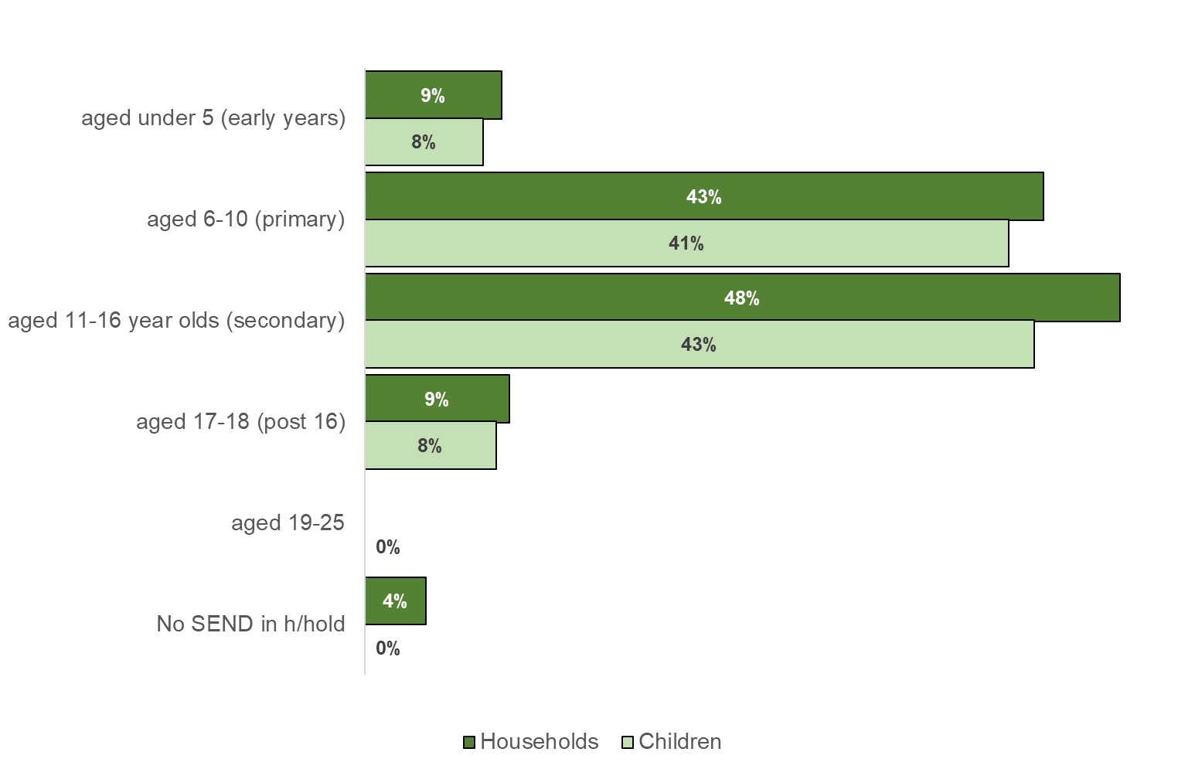
Base: number in households (205), number of children (250)

4.2 Use of short break services

Respondents were then asked about their use of short break services. A third (33%) of respondents currently use a short break service, and just over a quarter (28%) have previously used a service but are not currently using.

- Do you, your family or your children currently use or have previously used Lancashire's Short Break service?
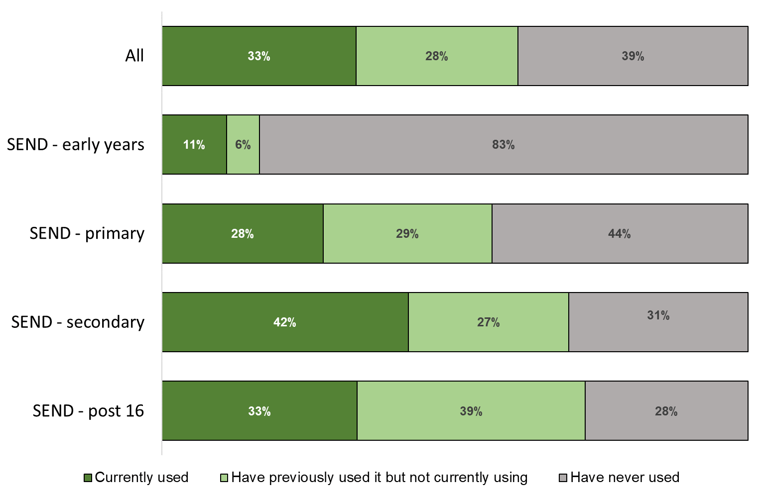

Base: All (203)

Respondents who currently use or have previously used Lancashire's Short Break service were then asked what type of short break service they had used. Of these respondents, almost three-fifths (59%) used the Lancashire Break Time activities service and one-in-nine respondents (11%) used the day time short breaks service.

- If you currently use or have previously used Lancashire's short break service, what type of short break service have you used?
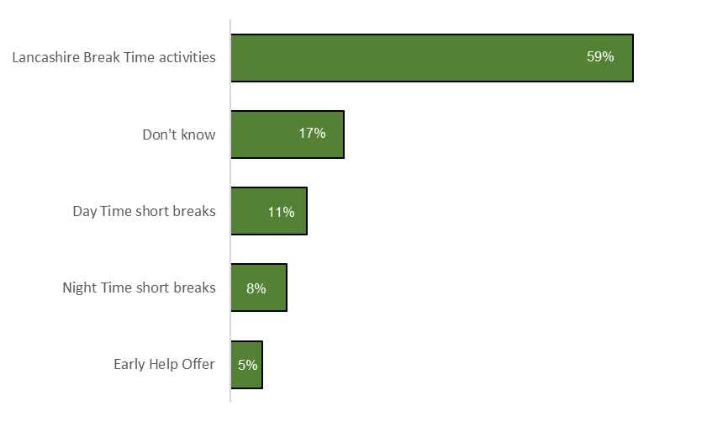

Base: respondents who currently use or have previously used a short break service (168)

4.3 Respondents' views on the proposals

Respondents were then asked about the proposed age range for accessing Break Time activities.

It is proposed that the age range for access to Break Time activities is 5 to 18 years old. A child would be able to attend from the start of the academic year (September) in which they turn age 5 to the end of the academic year in which they turn 18 (July).

Just over a third (36%) of respondents strongly agreed with the proposal and a third (33%) of respondents tend to agree with the proposal. Current users were most likely to agree with the proposal (77% either strongly or tend to agree).

- How strongly do you agree or disagree with this proposal?
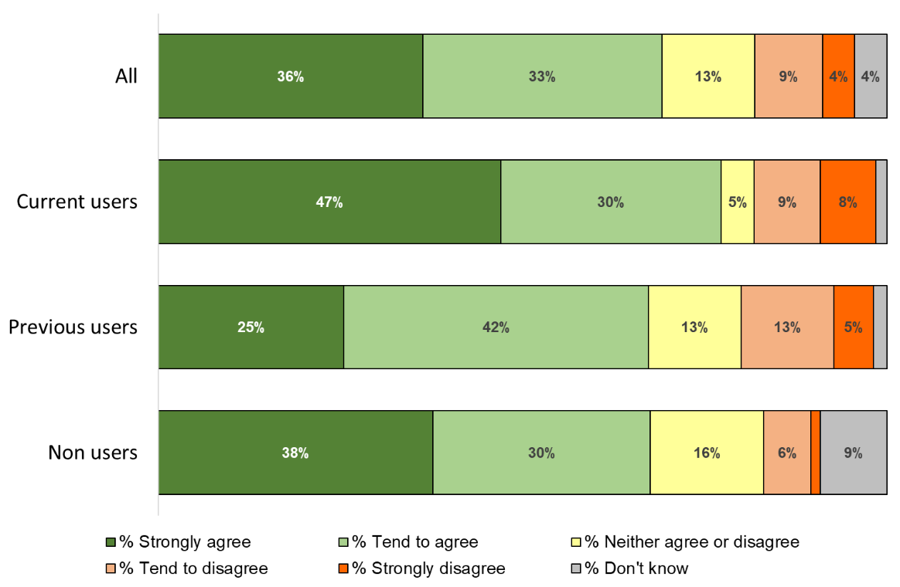
Base: all respondents (204)

Respondents were then asked why they said that about the proposal. The following comments were received from respondents who agree with the proposed age range for Break Time activities.

Comments from current users:
Feel that this is a suitable age range. However, there does need to be provision for younger children and those over 18.
As EHCP's can run to age 25 and some children with SEN run at an age appropriate deficit, it would probably help to provide an extension to the age range subject to a trial on uptake in the 18-20 age range say
Any help or break is a big happy to my son and the rest of the family
it really helps with progress and is good for them
Because it's not too much different. But would not want to see a cap at 50 hours
I think there should be an additional service for 18 years and over. Just because these children are 18 does not mean they can go out alone, they still need support as do the parent/carers need respite.
There needs to be some age criteria to ensure activities offered are appropriate
I think it is good to have a ‘bank’ of hours that you know you are eligible for.
Children with Sen desperately need breaks and activities to spend time with other children to improve socialisation and mental health. It also gives parents a few hours to take care of themselves too.
It’s good to start at school age to start groups and activities
Free hours provided by nursery offers a break for parents and is enough support during pre-school years.
I tend to agree as the age range is appropriate and older people of 18 and over May then require more appropriate activities to help support them with their future.
In my own experience, as my child got older, life became more challenging. Although I would have liked breaks when he was 5, it definitely wasn’t as big a need as when he was 7+. This would be a very individual thing, and I don’t know how many people would have a similar experience.
My son attended from age 5 and we wouldn't have coped without it.
I agree as children with SEN really miss out on group activities and mixing with peers outside school. Parent also need a much needed break however young or old the child is.
Fits in with start of school until they leave.
Assume provision is provided elsewhere once over 18 years of age
Excellent service
Helps the children from an early age to mix with other children and have friends like average children. Also well needed rest for parents so we can function better when looking afterburner children full time.
I feel it would be more beneficial from school age, 4 years old.

Comments from previous users
Seems reasonable.
I would not have sent my 5 year old to evening activities as she would have been too young and too tired to be out after school. I may have considered weekend activities if any were available.
Under 5s need more hands on help and over 18s should really start doing things aimed at their age group.
Younger children are more able to access universal activities as the gap between the children’s abilities is smaller at a very young age. Over 18s should have access to more adult activities through adult social care services.
Aimed at children, I suppose there will be other services for adults?
Seems a lot fairer
This is the age range when young people benefit from additional support to do activities out of the home setting.
Why end when they are 18 when SEN kids don't leave school until they are 19 ?Thats non-sense and stress for parents. You need good quality providers like schools.
Meet most age groups and seems fair
I will be concerned when my child turns 18 and the Break time activities end as to what will be available then.
My son was unable to attend LBT activity until he turned 5 (June), so activities during the school holidays in his first year of school were unavailable until the summer holidays after he turned 5.
I think that 5 may be a little young. Unless services change, in my experience they are only suitable for older primary and secondary age children.

Comments from non-users
Activities for pre-school aged children are easier to find
I think parents whose children are aged 3-18 should have this option, it could help parents get back into work
Because I agree
It's a good age range
All children deserve to have a short break and just because they turn 18 on a certain day doesn't mean they are no longer a child with special educational needs
I think it should be up to 21.
Well would good to get my son out and about plus the parents are having time to their self
Cause it's good opportunity to learn new skills
Gives more opportunity to children and young adults
I agree that when a child is aged 18 they should be integrated into adult services
Because sometimes it can be extremely difficult for parents
Children of these ages need this outage to mix with other children in a secure environment
Routine is key with a child and once they are of school age break time could be worked into their schedule with little disruption. My personal opinion is that children under the school age should have some other provision.
I have not yet had the opportunity for my son to use this service im hoping he can very soon
Benefit will be felt at school age for the child

The following comments were received from respondents who disagree with the proposed age range for Break Time activities.

Comments from current users
Why limit to 18 when our son is 19 and has learning difficulties?, he does not present as 19.
My son will enjoy social activities further into young adult hood. The very nature of his disability gives him immaturity, social fun/clubs will be important and necessary for his well being until he is older than 18.
Schools now have FE departments that keep the children at school until they are 19. What is available from age 18+ as the next area appears to be homes for the elderly which are unsuitable for young adults to access
Age should be up to 25 years in line with EHCP. SEN young people may be chronologically 18 but very often their academic and social age is very much younger therefore they continue to seek out activities that typically developed young children would not be interested in after age 18.
My son is born in July, started school at 4 it should be when they start school! What does age matter!
Because I feel the early younger children start the better.
SEND children & families have short break needs from 0-25
Should be able to access upto 19 years.
How will this effect school holiday clubs currently supported by LBT? 50 hrs is less than 1hr per week? So suppose Slime is 2hrs does that mean can only attend every other week? Not clear how parents can buy extra hours? Do providers have to offer extra places? Difficulty accessing hours in Rossendale has been due to lack of provision previously.

Comments from previous users
My child is a July baby! So it would have been a full year before he was able to access the support! Age discrimination! It should be if they attend school!
Under SEND children and young people are entitled to support 0-25. To have a CUT OFF at 18 without some support to breaks beyond 18 seems a little arbitry. My sons only social activities came about through LBT. He could no longer go to a youth club where he had friends for the first time because they had different birthdays. He felt excluded and yet again isolated. Please consider what support families get at this point and are services available and appropraite.
There should be something for younger children too.
Respite is needed more so out of term time
50 hours support. Means barely 1 hour per week. Thats not enough time to go shopping. Do something normal with siblings. Gives no structure or routine if used by an Autistic child. Theres no point for the parent even to go home.
Because it excludes a lot of children who don't have an ehcp in place but they still require access to services from the local authority.
I think it should run in line with the ehcp and run to 25
Children who attend a residential school may only be 38 weeks but still stay with parents at weekends and holidays, but would be excluded in attending break time in new proposals. All activities and Break Times must be inclusive for all children and families.
It says that the children and young people with EHCP are eligible. In law, the EHCP will be maintained until the age of 25. Therefore, the offer must be aligned to the lifetime of the EHCP. I think the young people over 18 must be elighble, too.
Our children are developmentally younger and these needs cannot be met anywhere else. ASD is a prime example of providing our children who are not yet young adults with a service.

Comments from non-users
There needs to be provision for younger children, not necessarily through a social care assessment.
Why should it stop when they turn 18, to us parents that age means nothing. Nothing changes.
I think children age 4 should be eligible for the offer. 4 year olds starting school, especially those who require additional assistance, would benefit from the offer during a potentially difficult transition period.
You're punishing the poorest again by charging more I don't access them now as I can't afford it for all my children so by putting the price up makes it even harder.
Should be younger. No help until school age really. All Children who have an EHCP have a right to a social care assessment, but having to fight for one isn't good enough so you shouldn't say if these things don't meet need you can have this social care assessment instead as it's not happening. If you get a care package or not you should be able to access these services, for like a day out, respite if no included. Also like ehcp should be up to the age of 25.

Respondents were then asked about the annual hours for Break Time. It is proposed that a child can attend a minimum of 10 hours and a maximum of 50 hours of activities or groups per year as part of the Break Time offer.

Almost three-in-ten (28%) respondents strongly disagreed with the proposal. Four-in-ten (40%) of current users and the same proportion of previous users strongly disagreed with the proposal.

- How strongly do you agree or disagree with this proposal?
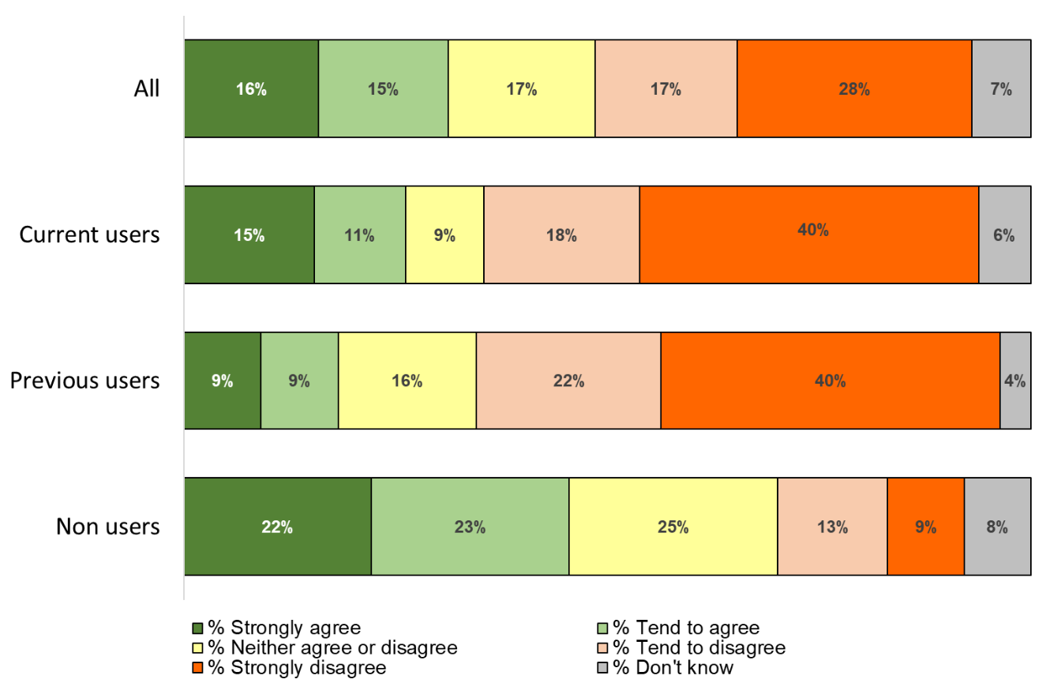

Base: all respondents (202)

Respondents were then asked why they said that about the proposal. The following comments were received from respondents who agree with the proposed annual minimum and maximum hours.

Comments from current users
This should allow everyone access. In years where there has been more provision available through child's school my child has attended more than 50 hours so if the provision is there I do feel that it should be for more than 50 hours.
Any hours is good
There's not an endless pot of money. This is effectively free childcare. People with children without SEN would have to pay for this respite.
I know funding is so hard to get. So anymore hours would b impossible. So it's good to have a fair system that is equal for all.
She needs to bond with other children
Sometimes groups are full so will be more fair.
Helps families
Comments from previous users
I agree with the need to make sure that all children and their families have opportunity to access a break. However, it has to be the right break and it is, therefore, important to establish why some families are currently accessing fewer breaks than others - is it because the breaks are being block-booked by the same few families, because families don't know about the scheme, or is it because the breaks themselves aren't suitable for some reason?
I think most people will want 50hours as that would be one or two sessions per month after school. 10 does not seem very much. If families had 60 that would make it an easy number 5 per month.
Fantastic
This would be ok if it was for a minimum of 6 hours per day.
I would be happy as I'm a working mum. Need some help with childcare as no family to help. Beneficial to the child for social interaction.
My 14 SEN needs activities outside the home

Comments from non-users
It depends on the child's needs and the whole families' needs too which might mean more hours are needed or less.
Makes it fairer, so that more people can access the service.
I think 50 hours is a fair amount of time.
It’s good because there around other children and always stuck in the same setting and there having time out.
Any help will be appreciated.
There has to be fair provision for everyone and enough places for everyone.
Capping the hours gives other children a chance to access the service.
I think that's sufficient for a single child and for others to benefit.

The following comments were received from respondents who disagree with the proposed annual minimum and maximum hours.

Comments from current users
Not looking my enough maximum allowance gives 1 hour a week. Hardly worth having for such a short time
A few overnight stays would easily take a massive chunk of hours.
Why limit the time! Again being excluded.
50 hours a year is less than 4 hours a week not much
50 hours a year is hardly anything?
Mainstream children get help with up to 30hours per month childcare - extended to 16 years old for disabled children - to enable parents to work. Surely SEND children would be legally discriminated against if offered anything less as mainstream childcare facilities often can’t take SEND. Short break or not.
My son currently attends a Saturday session 10 to 3 equating to 5 hours - a limit of 50 hours would restrict him from attending weekly and move it to only 10 Saturdays a year. These sessions are vital not just for parents break but also to aid these children to socialise and develop social skills.
My child attends school holiday clubs for 7 hours a day, plus other short break activities as the full time provision is not offered to him 5 days a week, so 50 hours is completely inadequate for us.
This is not enough hours.
50 hours is less than 1 hour a week over a year.
10 hrs in a year is nothing?! Children need regular/safe/suitable provision on a consistent basis.
Currently my children access weekly activities and activities in the holidays a maximum of 50 hours would give them less than an hour a week never mind 10 hours a year. I would not be able to afford to purchase extra time and I feel it is unfair to only offer this as an hour a week isnt exactly a break by the time you have dropped them off at groups it will be time to pick them up. I feel this is taking opportunities away from families not offering them more.
Some children may wish to attend more than others.

Comments from previous users
10-50 hours a year is not a lot when children with disabilities need more care than child their age. More respite should be given to carers
My daughter would mainly use the Break Time service for activities/days out during the school holidays. The school holidays comprise: Feb half term - 1 week. Easter -2 weeks. May half term - 1 week. Summer holidays - 6 weeks. October half term - 1 week. Christmas holidays - 2 weeks. We would expect something like 2 days' worth of Break Time activities per week during the week long holidays (Feb, May and October) and one day per week during the longer holidays.
50 hours works out to be very very very little indeed.
It won't really provide a structure e.g. using after school sessions on a weekly basis as that would add up to more hours over a year. I think a cap is good to make it fairer rather than the same children attending it a lot, but would be good to be able to buy more hours or increase the offer based on need
If allowed a maximum of 50 hours, that would equate to just over 3hrs for every week off school (3x1wk half terms, 2wks Easter, 2wks Xmas, 6wks summer = 13wks off. 50hrs/13wks =3.8hrs. Why does there need to be a maximum number of hours? There are very few children that will try to access provisions for the entire holiday period but would need more than 50 hours over the year. Are mainstream children restricted to 3.8wks? Do you think 50 hours over
Taking holidays into account 50 hours is too little
If the max 50 hrs are spread through the year, that is only 1hr per week - hardly enough for a disabled child to arrive, get their coat off and settle down. Let alone participate in any activities before the session ends.

Comments from non-users
It would depend on the parents or guardians need, if they are able to stay at home with the child their need is less than those who aren’t able to stay home for the likes of working or college/university. You have to remember this is over the course of a year
This is not sufficient to cover the time required during holidays and weekends throughout the year.
My son hasn't attended a break time but we did visit a provider with intention to however I decided he was a little young. I feel a maximum of 50 hours per years would not equate for a regular attendance on a weekly basis for example 2 hours per week. It would then limit time during the holidays. I understand a ceiling is required but not sure 50 would be high enough?
I feel more is needed. 24 hours in a day that's just over 2 days a year?
What is that going to achieve it's not like enough for some children to get used to the people
Could do with more hours
A maximum of 50 hours per year equates to less than an hour per week, there would be barely enough time to get settled never mind take part or become involved in any activity
Why put a minimum? Maybe a Max but can fund rest using DLA? If something is working it needs to be consistent.
The proposal would mean that my child could not attend his regular Saturday club- 4 hours per week for 38 weeks a year. He also would not have enough hours to access holiday clubs which provided valuable safe, social spaces for my child.
Hours should be based individually so what is needed
More support needed
50 hours restricts attending longer events
They should be able to access this on a weekly basis at least 2 hours per week, ie 100 hours a year
50 hours equates to just under an hour a week, double this seems more reasonable.

Respondents who disagreed with the proposed minimum and maximum hours, were asked what they thought the maximum number of hours per year should be. Almost three-in-five (59%) of respondents through the maximum should be more than a 100 hours per year.

- If you disagree with the proposal what do you think the maximum number of hours per year should be?
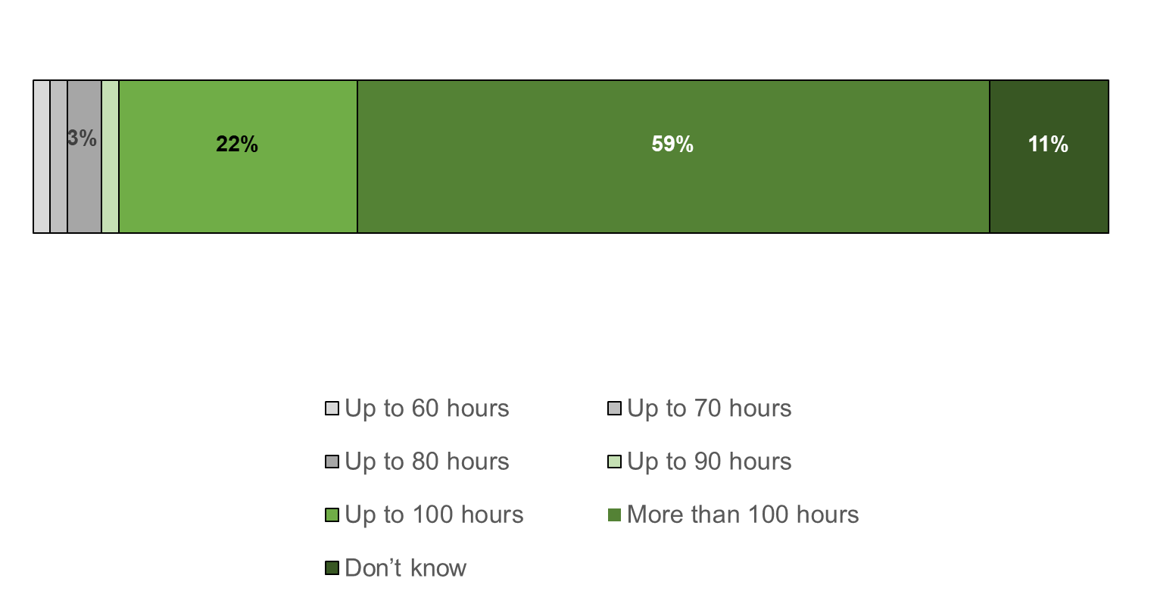
Base: all respondents who disagree with the proposed minimum and maximum hours per year (63)

Respondents were then asked about the proposed minimum parent/carer contribution towards Break Time activities. It is proposed that the minimum parent/carer contribution towards Break Time activities and groups is increased from £1 per hour to £2 per hour.

Almost one-in-three (28%) respondents strongly agreed with the proposal and almost a third (32%) tend to agree with the proposal. There were similar proportion of current, previous and non-users agreeing.

- How strongly do you agree or disagree with this proposal?
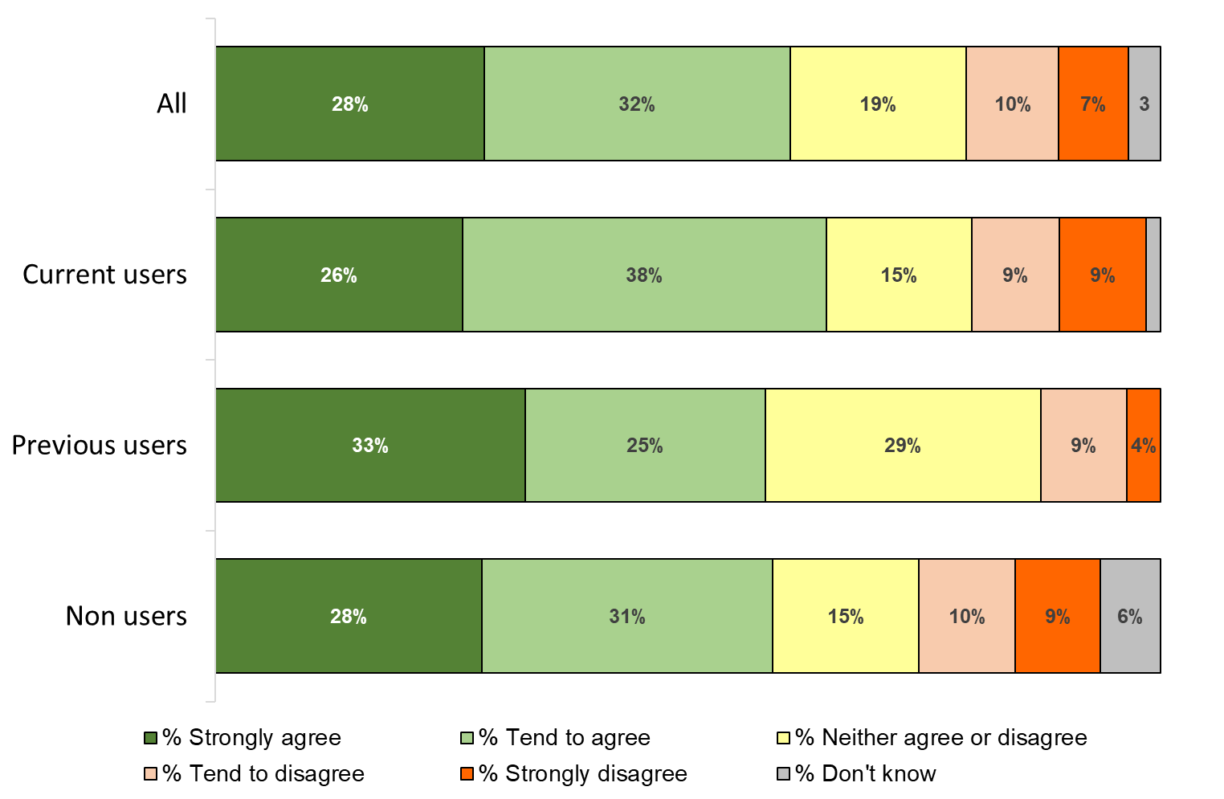
Base: all respondents (204)

Respondents were then asked why they said that about the proposal. The following comments were received from respondents who agree with the proposed increase to the parent/carer contribution.

Comments from current users
It's still very cheap.
I feel that is fair. Because the groups are vital for our children so an extra £1 should not matter because we need it.
I don’t mind contributing to quality activities and care
£2 per hour is totally fair
I am in favour of paying more for my child to attend appropriate groups where I know they are being well cared for.
I would agree to this of the number of hours offered was also increased. We currently pay 20 pound per day to access holiday support via our daughters special needs school. We pay this because we have no other choice and have to make limitations in other areas of life to afford this.
Any contribution is welcome.
If it means the Breaktime is more able to continue, I think people in the main would be happy to pay a bit more. However, maybe there could be a way of means testing, in that those who really can’t afford it, could continue to pay £1 an hour.
I think it's worth the money and they provide a valuable service
I feel if the child is having a full day of activity and being looked after by trained staff it's only fair that a parent/carer should contribute to the cost.
Happy to make some contribution
Fine with paying towards it! It’s the fact there is NO provision! I don’t mind paying
It is not much at all IF a good service is provided
With the money
Im happy for this to get ahead if we are given sufficient hours

Comments from previous users
I would happily pay more but wouldn't want any parent to not gain access due to financial circumstances.
I paid £12 a session at my sons Lancashire break time sessions
The value for money is excellent (especially Blackpool community trust) however have a means tested for those on a very low income
Happy to pay more as I would with mainstream was m activities if we could access them
I think you could raise that further to assist with paying for additional services. In future you could look at a lower cost for parents on lower income and raise the cost for more affluent families
I think this is still good value for money
I am happy to pay for activities for my child, I pay £5 per session at present which is in line with the activities I pay for my son who can attends mainstream activities.
More than affordable. Excellent value for money. Families are very fortunate to be able to receive these breaks for a couple of pounds.
Still affordable childcare however it could mean that some people wouldn’t attend due to cost
In my opinion this is a reasonable cost for high quality Break Time activities like the ones that my daughter has previously accessed.
Seems very reasonable
As a special needs parent I'm not looking for freebies. I'm looking for the same opportunities that mainstream children have. I believe that most people (when possible) are happy to pay for services.

Comments from non-users
People may respect the service more if they contribute to it.
If it helps I'm all for it
It would cost a lot more than that with private events
It's not that much to contribute if you're after a short break
That's an affordable price
Well I agree that carer/parents should pay something towards the activities for your child because at the end of the. Day your child having fun and the parents are having time out plus the activities have to funded somehow so yes we should pay toward it
Cheap holidays
I am willing to pay more for such a valuable service even though I have a very small budget to live off
Agree, costs should be contributed to
I wouldn’t mind paying.
Reasonable if sufficient support given to those in financial hardship. Otherwise DLA etc. is ok for this.
Fair enough, I would pay if that would help and got my daughter good care
Funding has been pulled out of everything and to ask for £2 per hour is a reasonable amount. I live on benefits with a 14 year old with sen and asd, I also have cancer. I think the increase from a £1 to £2 is in line with the current climate.
Seems fair
£2 per hour is reasonable
It's only like any child's group, they need funds to run them.
I feel that contributing to a service you frequently used is appropriate

The following comments were received from respondents who disagree with the proposed increase to the parent/carer contribution.

Comments from current users
The cost is a bit much as these children already need extra care and parents may not be able to space this about of money. It is a 100% rise in the cost!
I have been paying £2 an hour for my child for a year now.
I can afford this but others that care for their children by staying at home are unable to work and need the money for food, rent etc.
I am currently out of work caring for my daughter, with the benefits I receive I am lucky to cover all my bills and food for the month my daughter loves the groups but if it was to increase she wouldn't be able to go because of affordability which means she misses out seeing her friends and I miss out on the break.
Not all people have the money to pay for this.
Why should it cost more for the same service?
Parent carers do not receive a high income from Carers Allowance. Most cannot work full time and are limited by their caring role. Most don't have any energy left over after caring to work. This is obviously not their choice as they did not choose to have a child with special needs. They love the child however it is incredibly demanding, taking all of a parent carer's time. Besides this, most parent carers are fighting for limited services, rights
Lack of facilities and no more trip by Barnardo's means that 6 pound for 3 hours is not value for money especially when more than 1 child attends.
Don't mind it's hard finding suitable places so I don't mind paying for it
Some families will struggle financially if costs are doubled for parents
This may make it unaffordable for some people.

Comments from previous users
It becomes unaffordable for us to send our child if they are so expensive. We currently pay £20 a day if he wants to attend so he is missing out as we can’t afford that.
I tend to agree with the rise but feel timing won't be popular due to covid19. Many have faced redundancy / reduced hours ect so personally I feel it is bad timing and I would start the increase from January 2021.
Hard for families to pay double what they were.
The contribution will be increase by 100%. It is a significant increase in terms of the rate.
I would be happy to pay knowing my child would be taking care off and would be having lots of fun. However sometimes financial strain on families would mean these families may not be able to afford it
Many families are financially disadvantaged

Comments from non-users
Coronavirus has messed the world up financially, a lot of people are even worse off now than before, if a parent isn’t in receipt of DLA for the child, it could be quite expensive in the long run
Its stopping the poorest accessing it
What, it's a lifetime but a pensioner parent can't afford it.
It should be free
On benefits.
Cost of living is rising so not a lot of disposable income available
Some parents could struggle to pay
Only increase if the money is used to improve the service and not for the pockets of service providers
That's a 50% rise some parents just can't afford it so now there child with have miss out. Where does the money go?

Respondents were then asked about the costs of entrance fees and transport. It is proposed that the costs of specific Break Time activities, entrance fees and transport should be paid by parents/carers and not through Break Time funding.

About one-in-three (31%) respondents strongly or tend to agree with the proposal and almost two-in-five (37%) respondents disagreed with the proposal. Current users were more likely to agree with the proposal (39%) and less likely to disagree (29%).

- How strongly do you agree or disagree with this proposal?
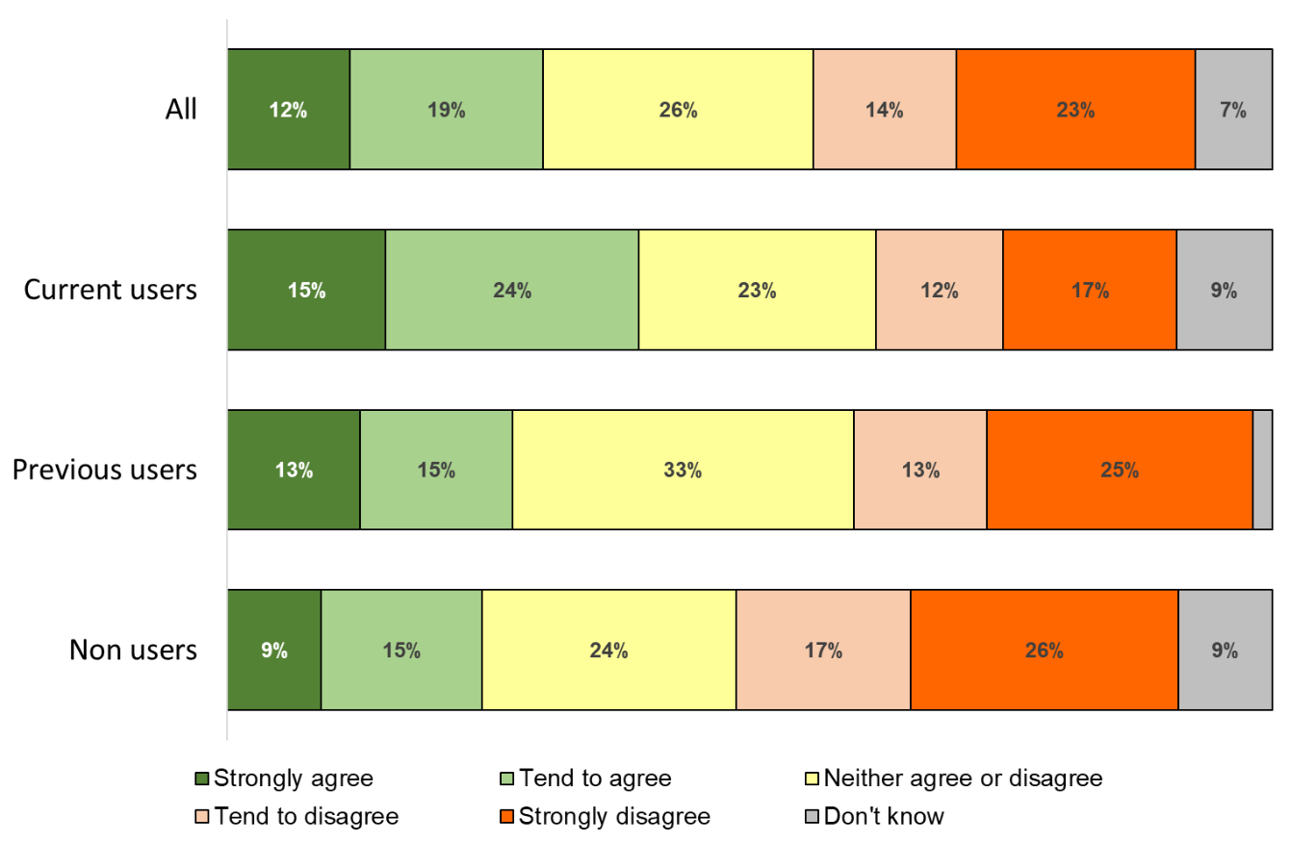

Base: all respondents (205)

Respondents were then asked why they said that about the proposal. The following comments were received from respondents who agree with the proposal for entrance fee and transport to be paid by parents/carers.

Comments from current users
Does depend on individuals finances
Same as the answer to the last question
Totally agree, as taken my son and looking after him
I do not mind paying for quality activities and care
I would be happy to pay for the cost of activities.
I feel that part of the costs should be funded by parents.
Some activities are expensive and as you are not paying much for their care it's not unfair to ask for expenses.
I think it's fair
Yes that’s fine! Happy to pay for my child to go to activities we get dla so it’s fine! What is annoying is we can’t seem to secure any provision!
I agree but feel there must be some support for some parents so children attending the groups are not excluded.
Because the person that uses the services gets money for that
I feel it’s fair for parents to pay for additional activities
Comments from previous users
Totally if providers aren’t sustainable they won’t be there long term. Too many come for the money then disappear when the funding has gone.
This cost would be paid by the family to enable a non-SEND child to access an activity/club and it should be the same for a special needs child. However, please see my previous point about family finances.
All entrance fees should be paid by parents you would do this for a non disabled child. It should only be the care element that is free.
With neuro typical children, these costs would be incurred.
If I was to take my son out on my own then I would have to pay anyway but if he can go as part of a group then that would be better so I have no problem in paying.
Again happy for these activities as the rest it’s it provides is priceless for the family
Parents will pay for the break as sometimes the issue is not finding the pre-arranged activities. If there is an additional cost for some activities these should be funded by the parents or use their extra credits/hours to pay for these to ensure the financial side is fair.
Where a family can afford to pay for these extra benefits they should. Where a family cannot afford the full price they should be helped. This is a situation that should and could be looked at on a more individual basis. No child should miss out through no fault of their own, but at the same time, those who can afford to pay shouldn’t rely on the break time funding. It is not true to say that all disabled children are born into financially challenged family
Direct payment recipients have to pay entrance fees, transport etc for activities.

Comments from non-users
Again agree as it's affordable for our family but may not be for all which may exclude families unfairly.
Would this be a financial barrier to people accessing the service?
Can't have everything for free
Well our children that benefit from it so it up to us to pay for our children’s fun you can’t moan at being ask to pay for your child to have fun
Most cannot work due to the demanding care responsibility they have.
With a disability discount then yes
I would be happy to contribute

The following comments were received from respondents who disagree with the proposal for entrance fee and transport to be paid by parents/carers.

Comments from current users
Unfair
We already pay for the club. This should cover any other costs
Many people that have disabled children cannot afford this and their children would not be able to access the services. This would be detrimental to the whole family.
As I said previously, how are carers supposed to afford this? I am a single parent who is out of work because I care for my daughter how am I supposed to pay for the increase per hour and entrance and transport fees? I feel the council needs to do more in terms of funding for SEND children and their families
To me, I am able to find these additional activities however I know people who cannot and they should not be punished for that. People who work hard and still can’t afford these things will be missing out through no fault of their own.
Many activities are expensive and most parent carers have a limited income because their caring role takes up all their time and they are left exhausted, without energy left to do another role and earn extra income.
Maybe some families can't afford it
This could exclude some children from the activity.
Most families have to rely on carers allowance. At £66 a week don't have funds available to pay additional costs so makes this inaccessible
Just another problem to deal with.
These could soon add up to be quite big amounts and would limit access/be discriminatory based on ability to pay.
SEND children need a higher staff ratio and have higher needs - already reduces appropriate providers available - and short break costs could escalate beyond affordability for some families
Transport should continue to be provided free of charge. Other charges should be a contribution, not the full amount..
I don't have spare money to pay this.

Comments from previous users
Makes it inaccessible for poorer families. Most of us have vastly increased costs due to the children for various reasons and many only scrape by as it is
It is likely to prohibit some families. Providers should be able to find activities that operate within the costs
Typically parents with special needs children are on a low income
Unaffordable if we are already paying a large fee to attend. It should be included in the price
I think it should be all inclusive
I'd happily pay a contribution but on a low income it would put me off accessing services my child desperately needs.
Entrance fees I can understand but not transport.
Because our children will be excluded even more than they already are and not everyone claims dla even if they are eligible
Lots of families can’t afford to do that
LCC should be covering providers' costs of delivering activities. I am sure many providers are struggling financially at present due to the impact of lockdown & COVID-19 restrictions & guidelines for running. I am really concerned, providers will not be able to remain open.
It will significantly limit the access to the services.
Again if you put costs up you will be taking away services to people that can't afford but need this service
I do not agree that all costs should fall on Parent Carers. A contribution should be an option not a set amount.
I don't quite see why, if there is specific funding available, parents should have to meet the costs?
Families with children with disabilities are financially disadvantaged and these cost may limit how much the family can assess the facility.
Could a contribution be made by carers/parents and be topped up by the authority? Otherwise financial pressures might prevent carers/parents from enlisting children in activities. Financial constraints limiting participation in the scheme are more likely now given the risky financial situation many families are facing at the moment with to the prevalence of a growing base of covid cases. This could be reviewed in two years' time, for example.

Comments from non- users
Again stopping the poorest
As some parents don't have any transport
What then would be the benefit of a dedicated “break time” centre over the cost of private breaks paid separately by individual parents & carers?
Defeats the point of it being offered if it is just essentially like any other business, other than that it is specifically for those with needs and disabilities.
This would stop the service from being accessed by everyone. I think that it would discriminate against people from poorer backgrounds who use the service causing financial inequality.
It should be free or means tested
Break Time may get better rates even if there are discounts for parents/carers
Not everyone has the money
While paying £2 an hour is acceptable paying entrance fees and transport is not viable for a lot of families especially on low incomes or benefits. People are struggling to feed their children at the moment.
Those eligible are likely to be on low income, therefore extra cost may not be affordable
As a large family such funds are not always readily available
Many families like myself are on the low end of benefits
Wow if your plan is to double the price ph, and charge entrance fees plus transport fees, Im a working mum and I certainly can't afford this.

Respondents were then asked about Break Time Plus. It is proposed that children with a plan of care and support following a social care assessment will be able to access Break Time activities and groups through Break Time Plus. These children would not be funded by Break Time funding.

Almost one-in-three (29%) respondents either strongly or tend to agree with the proposal and almost a quarter (24%) strongly or tend to disagree with the proposal. Current users were more likely to agree with the proposal (35%) and also were more likely to disagree with the proposal (29%).

- How strongly do you agree or disagree with this proposal?
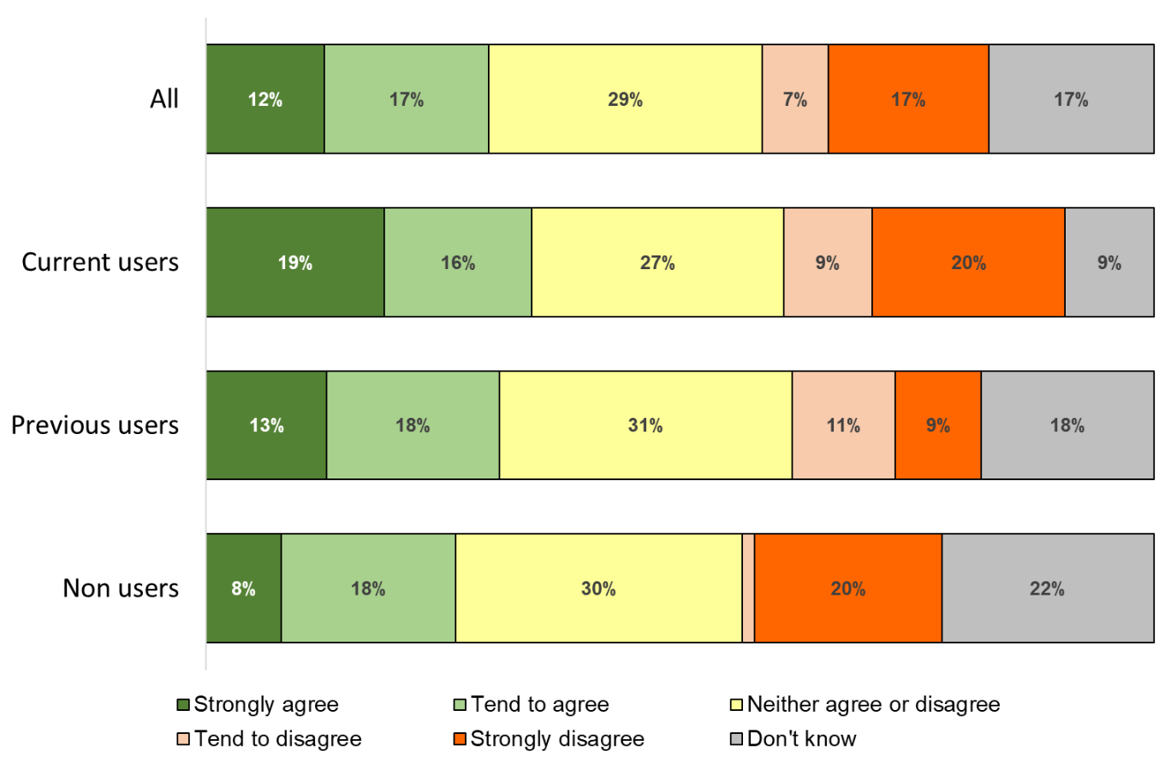
Base: all respondents (201)

Respondents were then asked why they said that about the proposal. The following comments were received from respondents who agree with the proposal for access through Break Time Plus for children with a plan of care and support following a social care assessment.

Comments from current users
Because the social care assessment should have put other measures in place.
Having heard feedback from other parents (who have a personal budget for their child) on getting our child in to these break times, it was very clear that to bar them from using this service that would meet the needs they had and could be paid for by them from that personal budget for their child was madness!! By all means they don't have to be FUNDED by Break time but give them access to the same provision but to pay from their personal budget is crucial.
Lots of our children need appropriate group activities not just 1 to 1
That's fair enough. If a family is getting other funding then they should pay with that. As long as no child misses out in the groups because of money. It needs to be equal and fair for all. No child should miss out because of finance.
Sounds like a good idea, but only if it's easy to access this ' Break Time Plus'.
We have a severely disabled child and were turned down when we requested just 4 hours support per month to allow us to spend some time with our daughter's siblings. Therefore, I would not accept also losing out on breaking activities if they had been booked up by children who already had secured support hours.
It is parental choice how to use direct payments.
I feel that children that are following social care assessment plan should be given the opportunity to use their direct payments to access break time as having 1-1 care can be isolating and not having the interaction with other young people can be detrimental to their social development. It would enable them to broaden their range of activities to keep them happy and stimulated. They can't access the range of clubs, groups and activities that mainstream
There is very little for children to access who go to short breaks it would be good even if they was on their short breaks then could join in the fun and have some activities to suit their needs

Comments from previous users
I would be interested to know how you would work out the cost of the family need to pay. The care package provides a number of hours and is different depending on where the child receives their care. All I am 100% sure of is that children with care packages should be allowed to access Lancashire break time activities, especially when they are unable to access mainstream activities due to their disabilities.
Will this impact on number of places available on BreakTime due to staff limitations and group numbers. Is BreakTime plus a different group to BreakTime? I do agree that those children with high level needs do have access to fun activities so in principle like the idea of BreakTime Plus.
My son has a mixture of an SLA for a provider and direct payments it works really well for him.
Seems fair, but should have been in place years ago!
As long as it does not impact on the availability of BT services for those who do not have a package. It is good for siblings and friends to be able to attend events together, especially things like youth clubs
The majority of children with additional needs has a social care assessment. Therefore, just because a child has a social care assessment should not disallow them from break time activities.
Fair enough. The child will be getting funding from their plan of care package anyway
I have one child with a social care plan and one child without. It would be great for me if I could take them both to the same activities
I believe all children with disabilities should have the opportunity to socialise away from the family with other children.
If they are already accessing funds for breaks then the funds for break time should be allocated elsewhere
If there could be flexibility in whether Direct Payments could be put towards the cost of Break Time activities, then I would agree with this.
there's not much choice out there so makes sense that children can access the same quality activities
My child has a care plan - how can he not have access special needs services available in the area. I would be prepared to use my care plan to assess these services. I also appreciate families without care plans need priority.

Comments from non-users
These children are already getting support
They already have
Well again if you want your child to go and have fun and make new friends then it up to us to fund that.
Still should be some funding as these are the crisis families.
If these children are getting funding from a plan of care and support or some other means then the break time funding can be spread out more evenly

The following comments were received from respondents who disagree with the proposal for access through Break Time Plus for children with a plan of care and support following a social care assessment.

Comments from current users
I think depending on the amount of hrs they get from social care should depend on how much Lancashire breaks they are allowed to use.
Would disagree if this means less places for children/families who would otherwise get no support
I'm sorry, I don't think the outline of this has been clear enough. My son has as a social care assessment and receives direct payments, so is it the case that he will no longer be able to access his school holiday club through LBT?! I used to use the holiday club for 5 sessions of 5 hours in school holidays = 25 hours. But receive 12 hours direct payments in school holidays. Obviously the goal posts are being moved from when we went through the social
All children should receive the funding
Our children are always being assessed!!! Why can the facilities that have been in place not be extended to more families etc. Groups such as the play inclusion scheme covers many areas and provide good activities for many children with SEN.
Again, children who are disadvantaged lose out.
What is break time plus? What are these services? A lot of this I have never heard of and may not be available in our area?
Not all children may qualify but as long as a provision is provided.
You don’t always get enough hours. Let them go too.
As per previous response costs are a struggle when forced to rely on carers allowance
I’ve already experienced this via a service provider! PIP - they won’t accept us because we get ‘respite’ so again limiting hours we can access support!! I might add that lockdown and further closures of schools are significantly impacting on our mental health and wellbeing and we have had NO support!!! It’s so hard having a child with extra needs and all provisions shut off from us!
Penalises SEND children as they still can’t attend mainstream provision - even with a paid carer. There just aren’t enough specialist providers offering appropriate activities that could continue to function financially. SEND legislation states Local Authorities should provide such care.
I am concerned this would make things less flexible for those children and families who are have higher needs

Comments from previous users
The parents with a plan use the plan for care help and even if there's an allocation for social activities finding these activities is so difficult. It.wouod be great if providers allocated extra spaces but these were paid for with direct payments
Some children who have an assessment and a package of care receive less than 50 hours of support. They wouldn’t have enough hours in their package to cover attending a short break and having their other care needs met. This would exclude them from joining the activities which might offer their only social interaction. It may also put people off going for an assessment which they need, for fear of being worse off and missing out on these activities.
This service should accessible to all!
If they have been identified as needing it then all children regardless of their situation or how they meet criteria should be treated the same. I do not agree with the above statement
It's just complicated and too many rules and restrictions, our life is miserable as it is and complicated. Make it easy for once.

Comments from non-users
If they still need to access the services their package should be increased.
Why aren’t all children being treated the same? It’s discriminatory
Feels like more paperwork not needed, assess for this that maybe stress of it all should be taken away and service should be automatically offered and by not offering funding to these children and their families is isolating them more.
Impact on financial commitments be too much for families with children with added costs to care for anyway
Again what's the point?
As a parent with a care package with minimal hours 7hrs a week that time is spent catching up on sleep for me if I had to use those hours for break time it wouldn’t be worth me having them thus meaning my son would miss out on fun activities with break time plus.
Lancashire council have increasingly & consistently over recent years in my experience obstructed SEND children & young people their legal rights & efforts to gain access to social care provision via an assessment, it seems to me that should Lancashire Council bar them from break time funding then there is in effect no social care provision for SEND children & young people to access. Lancashire Council will in effect remove this provision of break time
I think that social work assessments are slow to process and that they genuinely do not have the resources to assess as many children as they would need to, to ensure that all eligible children continue to have access to these services
Why can't they be funded?
Cost cutting when there is an actual need
This proposal seems divisive

Respondents were then asked how the Break Time offer is prioritised. It is proposed that that the allocation of a Break Time offer is prioritised for children with an education, health and care plan by date order of application.

Two-in-five (40%) respondents either strongly or tend to agree with the proposal and just over a third (36%) strongly or tend to disagree with the proposal. Previous users were more likely to disagree with the proposal (51%).

- How strongly do you agree or disagree with this proposal?
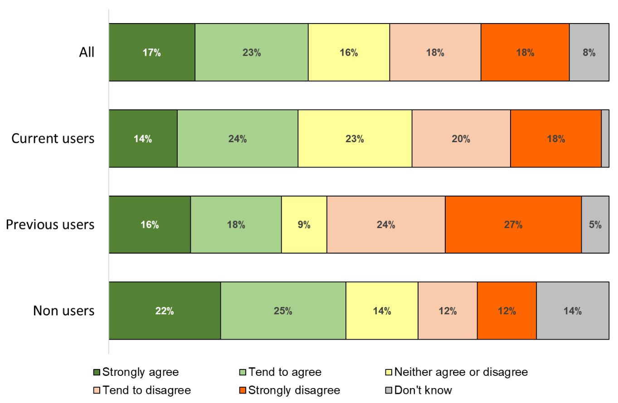

Base: all respondents (203)

Respondents were then asked why they said that about the proposal. The following comments were received from respondents who agree with the proposal for prioritising allocation.

Comments from current users
Hope information reaches people at the same time
Because children with an EHCP will find it difficult to access provision available to other children.
Needs though to be recognised that some children with an ECHP can access mainstream activities and vice versa
I think this is a fair way of identifying those with the highest level of need.
However unclear what ‘by date order of application’ means. All children with an EHCP should be eligible no matter when it was written
There needs to be a controlled system in place that is fair.
Children with an ECHP are more likely to be in need of support.
Because they have been accessed as needing it.
The resources for this provision are limited and therefore those children and families who are most in need should be prioritised.

Comments from previous users
Because if you do it have an EHCP then you are able to access other activities. The whole point of break tines if fir children who are Una is to access ‘normal’ activities.
It’s being used by the children that need it most
To be honest I've always thought this was the way it already was

Comments from non users
Those with EHCP in place have gone through hell and back to get it set up, so yes prioritise those with it set up first. However take into consideration some parents don’t know which route to go down as there’s not enough support or guidance.
Seems a fair system
I think it's fair to prioritise children with an EHCP to ensure that they benefit from the specialised opportunities offered.
I do think first come first served basis should be followed
Well my child is different from main stream children and I think they should be some for children that have health and education plan
Then it's fair, but often the people in crisis are the least likely to fill out forms.
these children have a higher need
Children with the most need should definitely be prioritised.
Childs needs are assessed, identified and can be met.

The following comments were received from respondents who disagree with the proposal for prioritising allocation.

Comments from current users
By date application may be hard for some families who struggle to get paperwork done.
It has only been late this summer after 2 years involved with the Parent Carer forum that I learned that Break times COULD apply to us as our son doesn't have an EHCP. It was in fact his keyworker and SENco from his school that signposted us to them as beneficial for our son, and boy were they (and for us too). Having seen how hard (and how long a journey) it can be for an EHCP to be granted, and that even parents themselves are applying for them after
Needs of the family and child need to be taken into account too. Not all families will have access to the Internet to apply promptly online if that's going to be the way to apply for a place.
Kids without ehcps also benefit from the service
Would’ve thought it would need to depend on need
It's not easy at all getting a diagnosis and there are many families waiting in the shadows to get their child assessed. This can take years. I don't believe a child should miss out on groups because of the failure of services and long waiting times.
Because the date of application does not determine the need for the service
I understand why this is done this way, but it also means children will miss out.
One of my children had an out of date EHCP it was out of date by 5 years so if these are what are going to be relied upon then this will not be fair. Also dependant on where you are when you get the details of short break facilities you may not be able to respond straight away and then lose an offer of a place for your child
That statement is not clear. What are you meaning by date order of application? Do you mean whoever responded first when asked if their child would like to participate in an activity?
The percentage of children with an EHCP is low compared to the percentage of children with additional needs/disabilities. Children are being encouraged to stay in mainstream schools with support plans in place. These children may need break time more than ever due to the lack of support available within schools. An EHCP is not given without a fight, of which some parents don't have the energy for, so I feel it is unfair to prioritise the children
No no
It unfair I have 2 children with autism that don't have plans as its impossible to get them. But I cannot send my children anywhere so that we can have a couple of hours to refresh batteries before we start again
This would not be workable for children who have only recently received ehcp, younger children for example. Not a fair system. Should be assessed on need.
Some people may come along late and need the time more
SEND children/families without EHCP or any diagnosis may be ignorant of their rights & often slip through the diagnostic cracks in services yet they are most in need of support as a result. Perhaps they should be prioritised for immediate family support & help through the Short Breaks Service
All children should be offered a fair and equal chance of accessing break time activities.
Depends on need/location/dates available
This is not a fair process as getting an education and health care plan can be a lengthy process

Comments from previous users
I agree with the EHCP bit but sure about date order of application.
So those that are able to fill in forms will access the services and those families that aren’t as able will yet again be placed at the bottom! It shouldn’t be how good you are at filling in a form to access a service! LCC know the child has special needs and it should be a simply link into that service! More jumping through the hoops! I am a parent of a non-special need child and a special need child! I don’t have to jump through hoops
It concerns me that many children with sensory needs in particular struggle to get an EHCP and the plans tend to be driven by educational need rather than social. There is a danger that many families may miss out on having a break. Yet another reason to chase EHCP. It seems to me to be a danger of you get it all or you get nothing. Support those who need a break to enable them to carry on without need of expensive care assessment or EHCP. Surely it's early
This puts more pressure on parents, yes I know we should book in time but some parents with children with complex needs and have other children who struggle shouldn’t miss out.
How to make the magic golden ticket even more sought after. My child is deaf and on the neurodevelopmental pathway who suggest she sounds like she has autism and ADHD and doesn't have an EHCP currently so what do we do for her going forward. She has absolutely no reciprocal friendships but doesn't realise cos everyone is her friend according to her. Other children when they know her shun her socially so break time is her only interaction with others during
Break Time should be open to all children with SEND, or those going through a diagnosis. This just restricts those families that are not able to get support elsewhere and this is against the original ethos behind LBT
Families should be able to access BT based on need not label. Under the current SEND legislation the allocation of an EHCP depends very much on the educational needs of a child/yp and the abilities of an individual establishment to meet those needs effectively. A child/yp may be on SEN support in one school but might well be on an EHCP if they were educated at a different school. The proposal gives no consideration to the wider needs of a child to socialise
I think is should be accessed by the situation
Some children have difficulty accessing main stream activities. Whist the family also struggle getting EHCP. Again this is putting up barriers, when this group of children probably need just as much help
Surely it should be based on need as it’s to support people
I don’t feel like that should come into it. It should be equal opportunity to book places
Parents have busy lives and should not miss out just because they are not the first to put in an application.
See previous response sorry it might be in the wrong box.
As stated previously my child does not have a plan and therefore isn't likely to be included now. He doesn't meet the criteria for a plan and sits just below the criteria. He still benefits from the activities but now isn't prioritised. He has a recognised disability so that should be taken into consideration.
I support my family of 4 with ASC. My son his partner and 2 grandchildren. Despite requesting assessments I feel very frustrated about the assessment process. My son at the age of 6 had no plan and as parents we were told he would thrive better at Ashley park school.
Many schools are failing children by not applying for an ehcp or taking too long. It would be unfair for any child to be left out, if a child has an identified sen they should not be discriminated against because of a document that is not actually worth the paper it’s written on in most cases
This information is not widely known and people could be restricted and denied a place through lack of information if all places were taken before they had chance to apply. Everyone, once they’ve applied should have access.
Parents with children with SEN have so much in their plate and a million tasks and if you are stressed and depressed this could be a task that gets missed. Dates need to be well communicated to help parents as much as possible to access these services
I think this could mean that children without an ehcp plan struggle to access Lancashire break time in areas where the demand is high. Children with an ehcp plan already receive support in schooI. I would be concerned that there is no support at all for those children who do not qualify for an ehcp. EHCP plans are more difficult to obtain now than they have ever been before I think this could result in a huge number of children falling through the net
I think there needs to be increased flexibility around allocation. I don't think this will work for many families as they may be left waiting months to get a break and may end up reaching crisis point before they can access break time.
Relying too much on EHCP will not always reflect the needs of the child. The EHCP is mainly focused on the child instead of the family circumstances. The short break must consider the other circumstances of the family instead of the child only. For example, if the parents' health are unwell the entire family will have disadvantage, it will not be fair for them.
There should be enough capacity for all children to attend. If your break time provision does not have enough spaces, look at the level of provision rather than excluding those children whose parents were not lucky enough to respond quickly. Is it fair if the same children get to attend all the time just because their parents respond instantly? Working parents cannot always respond to an invitation to an activity immediately. It is right that children
Application of the particular activity rather than date of ehcp application?
This will ensure that children who really need support are eligible to receive it. However, there are many children without EHC plans who need Break Time so this should not be the only criterion.
Too complicated
All children who need should have access it should not matter when their parents/ carers applied ethics
Date of application implies a competitive process; some parents do not grasp this concept. Could there be a deadline three or four times per annum where applications are received, moderated and assessed in one sitting?

Comments from non-users
My son does not have an EHCP. They take too long to obtain and we would like to access the support now.
I think the system and time for an ehc is a joke it's already out of date by the time you get a draft let alone the final draft that will be rushed and sent before deadline day so no don't think it will be fair
In an ideal world, yes. But EHCPs are like gold dust, and many families who desperately need support wouldn't get it. Until children who need an EHCP consistently get one, this proposal would exclude too many children.
Not treating all fairly. All children with an EHCP should be allocated break time if required. It does not matter what date it was issued.
My child does not get an EHC as she is deemed to be too bright. However, she is autistic and has other comorbidities and gets no support except from me. Children with an EHC get support.
Sometimes the hardest days of sen life is pre diagnosis
Should go on the individual's specific need
By prioritising EHCP does this mean that children who are as yet unrecognised disabilities will be unable to access break time provision & I am concerned that the wording “EHCP by date order” is not fully explained & what is meant by this exactly. Please note: I cannot see anywhere on the survey to leave my contact details so I leave them here below: XXXXXXXXXXXXX
I’m home educating because school failed my children dramatically so they would be bottom of the pile once again ignored because they don’t fit the bill
Not all children with disabilities have a ehcp
Plans can take months to finalise. Offers should be prioritised on the child's needs.
It all depends if parents will be all informed about it at the same time. We have never used the service so I'm sure i would have questions to before i would apply. Parents who used the service and are familiar with it would have a priority then. Not sure how fair is that
How can you say who is most in need, people fall through the cracks. My son does have an education health and care plan but some people have to fight to get one and don't always succeed
Some children it's taken years of getting one because of the process not from need
Will this not mean that children with a more recent echp will miss out? The criteria that I read say you should be in receipt of child benefit to qualify. Does this rule out children whose parents earn over £50/60k? This seems very unfair as in this case the children are missing out on the chance to access these activities. Even if each session costs more it is unfair to exclude them

Appendix 1 – respondent demographics

- Are you…?
 | %
Male | 5%
Female | 95%
Other | <1%
Prefer not to say | <1%
Base: all respondents (205)

- What age group do you belong to?
 | %
Under 25 | 0%
25-39 | 35%
40-49 | 41%
50-59 | 19%
60+ | 2%
Prefer not to say | 1%
Base: all respondents (205)

- Which best describes your ethnic background?
 | %
White | 91%
Asian or Asian British | 5%
Black or black British | 0%
Mixed | <1%
Other | 0%
Prefer not to say | 3%
Base: all respondents (203)

- How many children in total are there in your household? (in each age group)
 | None | 1 | 2 | 3+
Aged under 5 (early years) | 2% | 11% | 3% | 0%
Aged 6-10 (primary) | 1% | 24% | 8% | 1%
Aged 11-16 (secondary) | 1% | 28% | 9% | 1%
Aged 17-18 (post 16) | 1% | 9% | 1% | <1%
Base: all respondents (205)

- Which Lancashire district do you live in?
 | %
Burnley | 8%
Chorley | 9%
Fylde | 14%
Hyndburn | 4%
Lancaster | 14%
Pendle | 7%
Preston | 11%
Ribble Valley | 2%
Rossendale | 8%
South Ribble | 7%
West Lancashire | 5%
Wyre | 8%
Prefer not to say | 0%

Base: all respondents (204)

